Details re the width of you FlowStop
At the production we add between 0.3 and 1 inch of width except joints because it is necessary to be slightly wider than slightly less.
At the time of inflation the air fills completely your opening and the joints are squeezed by the pressure of the air, it is what ensures the sealing.
Installation Tips. (See instructions for Full Details)
Place your cushion at the opening to be the opening to be protected. When you install them, you pre-inflate the top cushion. When placing it in your opening, do not hesitate to force it in.
Once installed, make sure that the cushion is correctly positioned for height with the help of the two strips on the bottom cushion of FlowStop barrier
The strips must be perfectly level with the ground in order to optimize your protection and therefore the watertightness of your device.
Examples
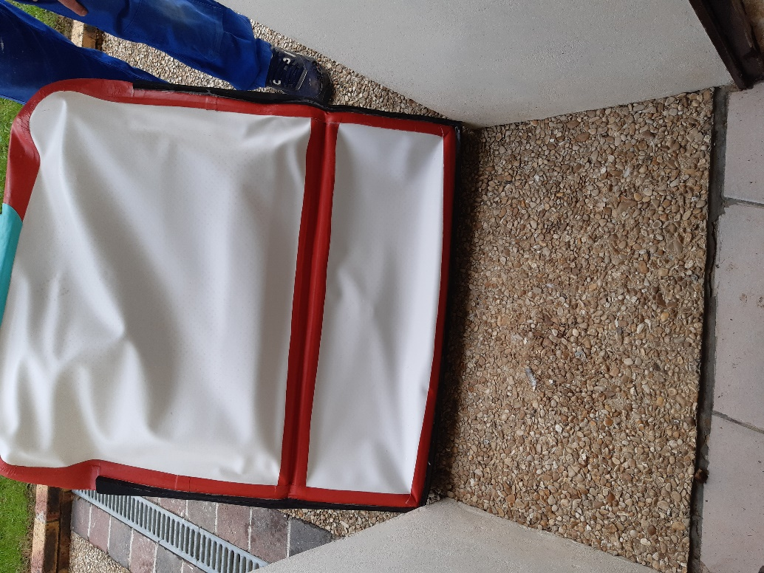
Width out of opening
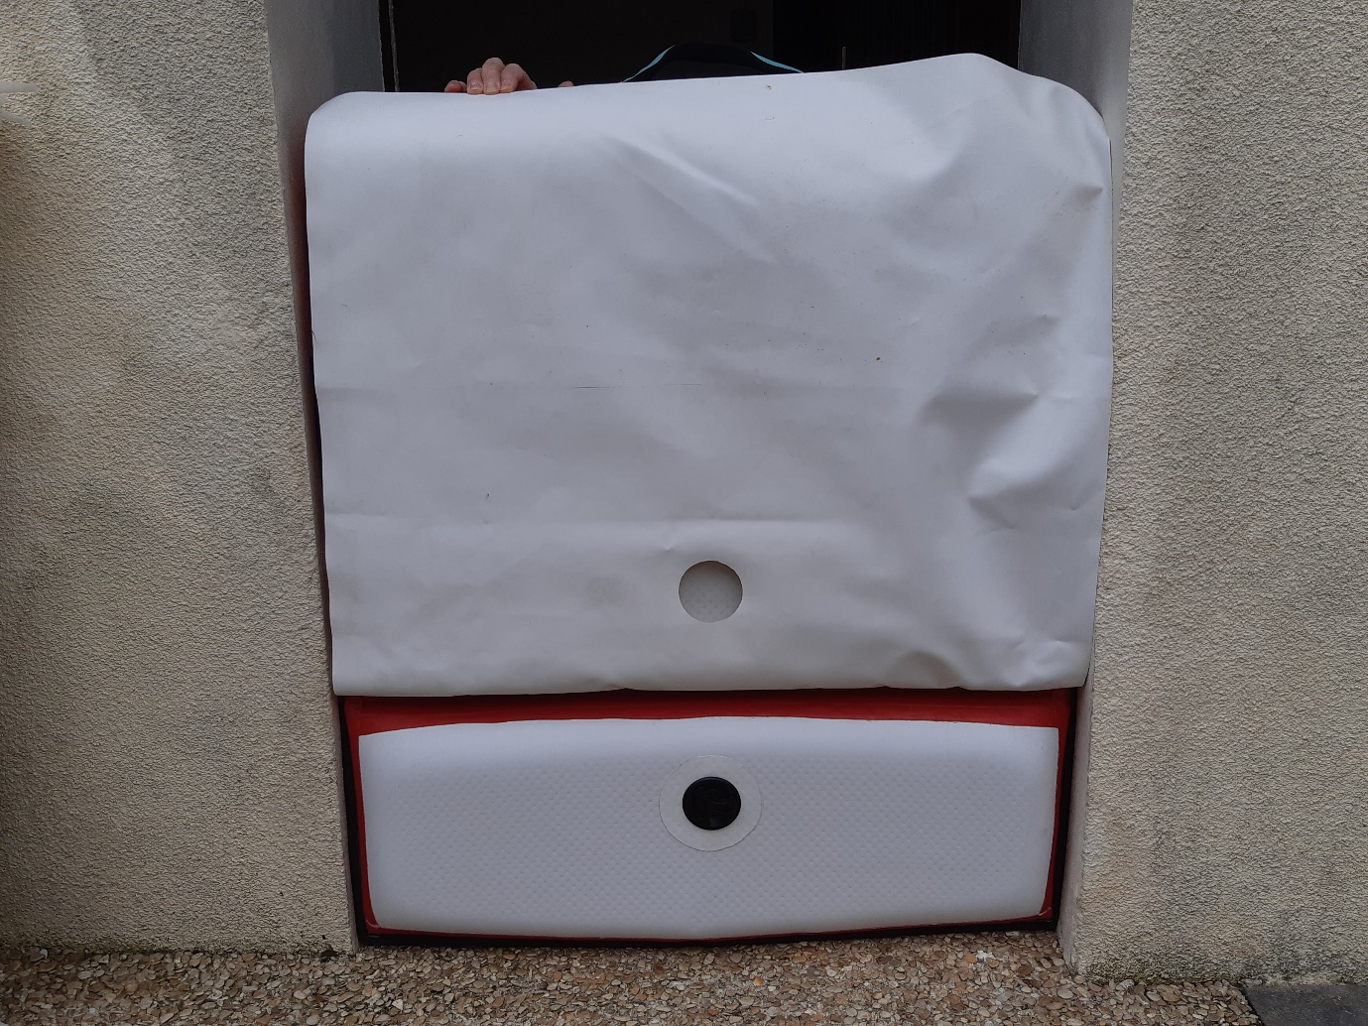
Width in opening

